

Department of Software Engineering

University of Gujrat, Sialkot Sub Campus

BricksKiln



Session: BSSE (2014-2018)

Project Advisor: Mr. Moeed Sehnan

Submitted By:
Noman Liaqat | 14061598-143
Mohsin Hanif | 14061598-160
Farwa Kanwal | 14061598-165
M. Osama Waheed | 14061598-172

Department of Software Engineering

University of Gujrat, Sialkot Sub Campus

STATEMENT OF SUBMISSION

This is certified that Noman Liaqat Roll No. 14061598-143, Mohsin Hanif Roll No. 14061598-160, Farwa Kanwal Roll No. 14061598-165 and M. Osama Waheed Roll No. 14061598-172 has successfully completed the final year project named as BricksKiln at the Department of Software Engineering, University of Gujrat, Sialkot Sub Campus, to fulfill the requirement of the degree of Software Engineering.

______________________ _____________________
Project Supervisor Project Coordination Office
Faculty of CS&IT -UOG

______________________
Head of the Department

Acknowledgement

We would like to thank Mr. Moeed Sehnan for his help and guidance throughout this project. We are also thankful to our friends and families whose silent support led us to complete our project.

Date: July 29, 2018

Abstract

In this modern era, everyone wants to stay in touch with new technology. Companies desire to expand and improve their business to get more profitable outcome. Bricks industries in Pakistan are small-scale industries that are the source of work of thousands of people in their daily earnings. BricksKiln is a software that is developed for kiln industries. It helps them to manage record of every order including sale and purchase. BricksKiln offers a way to mark attendance of workers. It contains data about workers in an online database system. Owner can keep record of workers, stock of bricks and raw materials. Application have the record of coal, clay and sand and notifies the owner about how many of these are used and left. An BricksKiln software allow owner to get alert about the condition of weather. It is a time saving application because it notifies owner about the time required to complete the order. BricksKiln is the best software to manage every aspect of a brick kiln including accounting, production, remaining dues and stock. It manages the ledger of the suppliers and keep record of stock about every item that was purchased during the manufacturing process and as per consumption. BricksKiln software is established in Urdu language for the ease of owner and has user-friendly interface.

Table of Contents
Chapter 1: Project Feasibility Report 1
1.1. Introduction 1
1.2. Project/Product Feasibility Report 1
1.2.1. Technical Feasibility 1
1.2.2. Operational Feasibility 1
1.2.3. Economic Feasibility 1
1.2.4. Schedule Feasibility 2
1.2.5. Specification Feasibility 2
1.2.6. Information Feasibility 2
1.2.7. Motivational Feasibility 2
1.2.8. Legal & Ethical Feasibility 2
1.3. Project/Product Scope 2
1.4. Project/Product Costing 3
1.4.1. Project Cost Estimation By Function Point Analysis 3
1.4.2. Project Cost Estimation by using COCOMO’81 (Constructive Cost Model) 5
1.5. Task Dependency Table 6
1.6. CPM - Critical Path Method 7
1.7. Gantt chart 9
1.8. Task and Member Assignment Table 10
1.9. Tools with reasoning 10
1.10. Vision Document 11
1.11. Risk List 11
1.12. Product Features/ Product Decomposition 11
Chapter 2: Software Requirement Specification (For Object Oriented Approach) 13

2.1. Introduction 13
2.2. Existing System 13
2.3. Scope of the System 13
2.4. Summary of Requirements:(Initial Requirements) 14
2.5. Identifying External Entities: 17
2.6. Capture "shall" Statements: 17
2.7. Allocate Requirements: 18
2.8. Priorities Requirements: 19
2.9. Requirements Traceability Matrix: 20
2.10. High Level Usecase Diagram: 22
2.11. Analysis Level Usecase Diagram: 23
2.12. Usecase Description 24

Chapter 3: Design Document (For Object Oriented Approach) 31
3.1. Introduction: 31
3.2. Domain Model 31
3.3. Sequence Diagram 32
3.4 COLABORATION DIAGRAM……………………………………………………………………….33
3.5 class diagram…………………………………………………………...............34
3.6. ENTITY REALATIONSHIP DIAGRAM……………………………………………….35
Chapter 4: User Interface Design 36
4.1. Introduction 36
4.2. Site Maps 36
4.3. User manual 37
4.4. Navigational maps: 43
Chapter 5: Software Testing 44
5.1 Introduction: 44
5.2. Test plan 44
5.2.1. Purpose 44
5.2.2. Outline 44
5.3. Test design specification 49
5.3.1. Purpose 49
5.3.2. Outline 49
5.4. Test Case Specification 50
5.4.1. Purpose 50
5.4.2. Outline 50
5.5. Test procedure specification 53
5.5.1. Purpose 53
5.5.2 Outline 53
5.6. Test item transmittal report 55
5.6.1. Purpose 55
5.6.2. Outline 55
5.7. Test log 55
5.7.1. Purpose 55
5.7.2. Outline 55
5.8. Test incident report 58
5.8.1. Purpose 58
5.8.2. Outline 58
5.9. Test summary report 60
5.9.1. Purpose 60
5.9.2. Outline 60

LIST OF TABLES
TABLE 1………………………………………………………………………………….3
TABLE 2………………………………………………………………………………….4
TABLE 3………………………………………………………………………………….5
TABLE 4………………………………………………………………………………….6
TABLE 5………………………………………………………………………………….6
TABLE 6………………………………………………………………………………….7
TABLE 7………………………………………………………………………………….8
TABLE 8…………………………………………………………………………………10
TABLE 9…………………………………………………………………………………10
TABLE 10………………………………………………………………………………..47
TABLE 11………………………………………………………………………………..51
TABLE 12………………………………………………………………………………..52
TABLE 13………………………………………………………………………………..53
TABLE 14………………………………………………………………………………..56
TABLE 15………………………………………………………………………………..58
TABLE 16………………………………………………………………………………..58
TABLE 17………………………………………………………………………………..59

LIST OF FIGURES
FIGURE A………………………………………………………………………………...8
FIGURE B………………………………………………………………………………...9
FIGURE C……………………………………………………………………………….22
FIGURE D……………………………………………………………………………….23
FIGURE E………………………………………………………………………………..31
FIGURE F………………………………………………………………………………..32
FIGURE G……………………………………………………………………………….33
FIGURE H……………………………………………………………………………….34
FIGURE I………………………………………………………………………………..35
FIGURE J………………………………………………………………………………..36
FIGURE K……………………………………………………………………………….37
FIGURE L……………………………………………………………………………….37
FIGURE M………………………………………………………………………………38
FIGURE N……………………………………………………………………………….38
FIGURE O……………………………………………………………………………….39
FIGURE P………………………………………………………………………………..39
FIGURE Q……………………………………………………………………………….40
FIGURE R……………………………………………………………………………….40
FIGURE S………………………………………………………………………………..41
FIGURE T………………………………………………………………………………..41
FIGURE U……………………………………………………………………………….42
FIGURE V……………………………………………………………………………….42
FIGURE W………………………………………………………………………………43
FIGURE X……………………………………………………………………………….48

REFERENCES……………………………………………………………62

Chapter 1: Project Feasibility Report

Introduction
Now a day’s people want to expand their business and it is difficult for them to carry their storage devices like Laptops or PCs where they store their business data. Mobile Applications provide the ease for business to handle their data in smartphones. Now days many people handle their business on android devices like Domino’s Pizza, Amazon etc. Our project is based on Kiln Business. Kiln industry is an important industry of Pakistan. There is no computer system and mobile application that manage the kiln work and provide ease to the kiln owner and increase the improvement. Owner of kiln facing lots of difficulties like the record and attendance of workers and their payments, record of raw materials, orders, red bricks, clay bricks, weather information, counting bricks and the most important loss or profit etc. Thus, the name emerges “BricksKiln”.
BricksKiln application developed for all kind of brick industry that manage their accounts, manufacturing process, sale, stock. BricksKiln system is first time developed in Sialkot, Pakistan.

1.2. Project/Product Feasibility Report

1.2.1. Technical Feasibility
The project we are developing is for all kind of brick industry that manage their accounts, manufacturing process, sale, stock and related work by using an android app. It requires an Android developer to complete this project. Our team is fully capable of developing this app as we have android developers in our team.

1.2.2. Operational Feasibility
Our project is very easily compatible with the customers as it has a user-friendly interface. Moreover, our android app helps user to take the decision in few minutes. In this way, our project solves the daunting problem faced by our user quite gracefully.
Moreover, this app is individual user app and it do not require a technical staff to operate it.
1.2.3. Economic Feasibility
Cost Estimates:
Development Cost
In the first version of our app we will not have any charges for the development of our app. The reason for this is that we have mobile application developer in our team.
In the second phase of the app when we have to launch it we must make it fully scalable to run on almost every device. This can only be done with hiring a team of developers and this will cost us money definitely.
The fully scalable app can be developed in 1 Million

Maintenance Cost
Maintenance is a very important job for the success of a software. For the maintenance purpose we have to hire a special developer and It can cost up to 0.2 Million annually.
Benefit Estimates:
Tangible Benefit
Our first and foremost benefit is that we are a working in a team and has the capacity for building initial phase of the project which will reduce a lot of money and this will indirectly increase our revenue.
Non-Tangible Benefit:
Non-tangible benefits of our project are that it provides complete satisfaction to our customers and users which will lead to increase in the use of our project and that will eventually increase our profits.

1.2.4. Schedule Feasibility
Schedule Feasibility is one of the most important things in timely completion of the project. For timely completion of our project, we have developed a Gantt chart which can be seen at the specific heading of Gantt chart. We are working 4-5 hours per day in our project and according to our Gantt chart we will be completing our project until the evaluation date. Our schedule is quite flexible and it is least probable that we will be late in achieving our milestones.

1.2.5. Specification Feasibility
We have acquired requirements for the project by keeping the fact in view the user priorities and their demands and problem they faced. We have mentioned the constraints for the project and also constraint and conditions are lucid and can be understood easily.

1.2.6. Information Feasibility
As the scope of online marketing in Pakistan balloons up, we find it a good opportunity to launch our app at that point so it can facilitate users in unprecedented way.

1.2.7. Motivational Feasibility
Our team is fully motivated to perform daunting task of developing this system. We realize that how big this is going to be and we as a team are the source of motivation for ourselves.

1.2.8. Legal & Ethical Feasibility
Our project is free from any kind of legal or ethical issues.

1.3. Project/Product Scope
The scope of our project is limited to technology in its first phase. It means that the user should be able to utilize our app which are related to technology.

The products which include the domain of technology are mainly as:
- Mobile Phones

1.4. Project/Product Costing

1.4.1. Project Cost Estimation by Function Point Analysis
Following are five information domain characteristics are determined and counts are provided in here as.

Count of total external Inputs = 5
Count of total external Outputs = 6
Count of total user inquiries = 3
Count of total internal logical files = 2
Count of total external interface files = 4

Information Domain Value | Low values | Average Values | High values | FP Count
External Input | 2*3=6 | 2*4=8 | 1*6=6 | 20
External Output | 3*4=12 | 2*5=10 | 1*7=7 | 29
User Inquiries | 1*3=3 | 2*4=8 | 0*6=0 | 11
Internal Logical Files | 0*7=0 | 0*10=0 | 2*15=30 | 30
External Interface Files | 0*5=5 | 4*7=28 | 0*10=0 | 28
Total Count | - | - | - | 118

Table 1: Function Point Table

Complexity Adjustment Factors:

Factor | Value (0-5)
Data Communication | 3
Performance | 4
Data Entry | 3
End User Efficiency | 5
Update | 4
Complex Processing | 3
Reusability | 4
Installation Ease | 5
Operational Ease | 5
Total = | 36

Table 2: Complexity Adjustment factor

CAF = [0.65 + 0.01 * ( )]

= [0.65 + 0.01 * (36)]
= 1.01
FP est. = Count Total * CAF
= 118 * 1.01

FP est. = 119.18

For Our Project
Average Productivity = 25 FP/PM
Labor Rate = 30,000 RS/Month

Total estimated Effort = FP est. / productivity
Total estimated Effort = 141.6/ 25 = 4.7672 pm
Cost/FP = Labor Rate/productivity
Cost/FP = 30000/25 = 1200 Rs/Fp
Total Project Cost = FP est. * (Cost/FP)
= 119.18 * (1200)
= 143,016 RS.

1.4.2. Project Cost Estimation by using COCOMO’81 (Constructive Cost Model)
In order to Calculate cost estimation using COCOMO model we will first have to choose that which mode of COCOMO model to choose.
There are three Modes of COCOMO model as:

- Organic
- Semi Detached
- Embedded

According to below table our software project has similar specifications and characteristics as organic mode of COCOMO model. So, in order to evaluate cost estimation, we will be using parameters of COCOMO model.

Parameters | Organic | Semi Detached | Embed
Size | 2-50 KLOC | 50-300 KLOC | 300KLOC or above
Team | Small | Medium | Large
Developer Experience | Experienced Dev | Average | Little Experience
Environment | Familiar | Less familiar | Changed
Innovation | Little | Medium | Major Innovation
Deadline | Flexible | Medium | Tight deadline

Table 3: Models of COCOMO

Mode | A | b | C | D
Organic | 2.4 | 1.05 | 2.5 | 0.38
Semi Detached | 3.0 | 1.12 | 2.5 | 0.35
Embed | 3.6 | 1.20 | 2.5 | 0,32

Table 4: Parameters of different Modes

Effort:
E = a(KLOC)^b Person/Month
E = 2.4(10) ^1.05
E = 26.928 Person/Month

Development Time:
Dev Time = c(Effort)^d Months
Dev Time = 2.5(26.928) ^0.38 Months
Dev Time = 8.737

Average Staff Size = Effort/ Dev Time
Average Staff Size = 26.928 / 8.737
Average Staff Size = 3.082

Productivity = KLOC/Effort
Productivity = 10/26.928
Productivity = 0.371

1.5. Task Dependency Table

Task | Duration (days) | Dependencies
T1 | 2 | T1(Mohsin Hanif)
T2 | 2 | T2(Noman Liaqat)
T3 | 4 | T2(Farwa Kanwal), T3(Mohsin Hanif)
T4 | 2 | T4(Farwa Kanwal)
T5 | 6 | T2(M. Osama Waheed), T3(Farwa)
T6 | 4 | T5(Noman Liaqat)
T7 | 10 | T4(Mohsin), T5(Osama), T6(Farwa)
T8 | 2 | T7(Mohsin Hanif)

Table 5: Task Dependency Table

1.6. CPM - Critical Path Method
- Specify the Individual Activities
In BricksKiln app we have divided our tasks broadly in following activities. These activities are performed on weekly bases and their Gantt chart is also developed.

- Feasibility Study
- Requirement Specification
- Design Document
- Interface Design
- Backend Development
- Database Development
- App Development
- Testing

2. Determine the Sequence of the Activities

Activity | Name (Activity) | Immediate Predecessor | Duration (Weeks)
A | Feasibility | None | 2
B | Requirement  Specification | A | 2
C | Design Document | B | 4
D | Interface Design | B, C | 2
E | Backend Development | B, C | 6
F | Database Development | E | 4
G | App Development | D, E, F | 10
H | Testing | G | 2

Table 6: Sequence of the Activities

3. Draw the Network Diagram

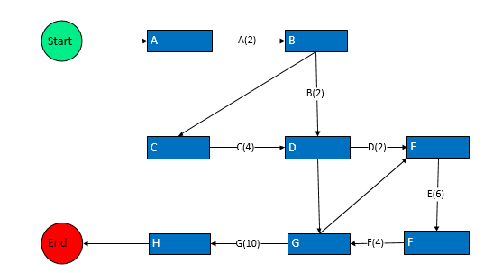

Figure A: Network Diagram

4. Estimate Activity Completion Time

Activity | Duration |  | ES | EF |  | LS | LF | TS |  | FS
A | 2 |  | 0 | 2 |  | 0 | 2 | 0 |  | 0
B | 2 |  | 2 | 4 |  | 2 | 4 | 0 |  | 0
C | 4 |  | 4 | 8 |  | 4 | 8 | 0 |  | 0
D | 2 |  | 8 | 10 |  | 8 | 10 | 0 |  | 0
E | 6 |  | 10 | 16 |  | 10 | 16 | 0 |  | 0
F | 4 |  | 16 | 20 |  | 16 | 20 | 0 |  | 0
G | 10 |  | 20 | 30 |  | 20 | 30 | 0 |  | 0
H | 2 | 30 |  | 32 | 30 |  | 32 |  | 0 | 0

Table 7: Activity Completion Time

5. Identify the Critical Path

As the critical path is the path with the highest value of duration so:
Critical path of Our Project is:

AB D EF G H = 28 Weeks

1.7. Gantt Chart
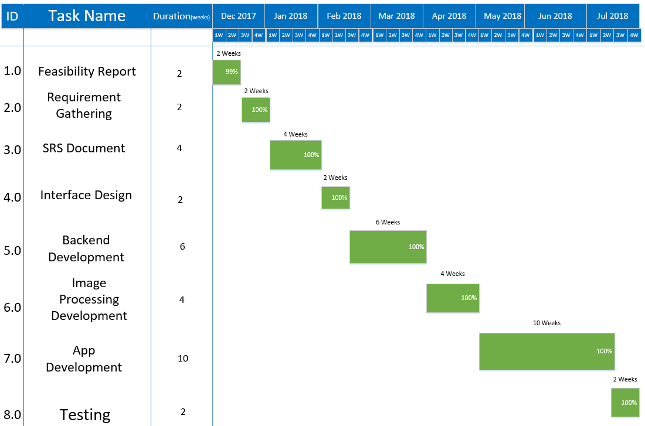

Figure B: Gantt Chart

1.8. Task and Member Assignment Table

Task | Engineer
T1 | Mohsin Hanif
T2 | Mohsin Hanif
T3 | M.Osama Waheed
T4 | Farwa Kanwal
T5 | Noman Liaqat
T6 | Farwa Kanwal
T7 | M.Osama Waheed
T8 | Noman Liaqat

Table 8: Task Assignment Table

Task | Duration (days) | Dependencies
T1 | 2 | T1(Mohsin Hanif)
T2 | 2 | T2(Noman Liaqat)
T3 | 4 | T2(Farwa Kanwal), T3(Mohsin Hanif)
T4 | 2 | T4(Farwa Kanwal)
T5 | 6 | T2(M.Osama Waheed), T3(Farwa)
T6 | 4 | T5(Noman Liaqat)
T7 | 10 | T4(Mohsin), T5(Osama), T6(Farwa)
T8 | 2 | T7(Mohsin Hanif)

Table 9: Task Dependency Table

1.9. Tools with reasoning
Languages
- Java: We are using java language because android applications are mostly developed in java using android studio and it has better support to android development
- XML: XML is a markup language which will be used to design front end of our mobile application. So, we will design our interface in XML language and in android studio.

- JSON: Java Script Object Notation (JSON) language will be used to parse the data from the server to your mobile phone in readable form.

- SQL: SQL will be used for our database creation and database handling

Tools
Android Studio: Android Studio will be used to develop and design android apps. Previously eclipse was used but now android studio has replaced eclipse because it has more support for android development.

1.10. Vision Document
Vision document is the agreement between the person building the software and all the stakeholder. Once all the person agrees on the feasibility, we summarize it in the vision document which is helpful in the requirement and design phase.
Some of the features on which all stakeholder is agreed are listed here:
- Login and Sign up System for the Users
- Add a new kiln and Select an existing kiln
- Staff data
- Stock of bricks
- Weather Information

1.11. Risk List
Following are the risks which can be biggest blow to the BricksKiln project.
- Development of similar app before our app launching.
- It is difficult to create a mobile app for different densities of screen. So, it is possible that app may not run gracefully on all android phone.
- Security issue can be a source of trouble in the long process.

1.12. Product Features/ Product Decomposition
- Signup and Login
- Main Menu
- Remove existing kiln
- Select the current kiln
- Add new kiln
- Raw materials
- Staff data
- Stock of bricks
- Order
- Sale and Purchase
- Counting Bricks
- Weather Information

Chapter 2: Software Requirement Specification (For Object Oriented Approach)

2.1. Introduction
Now a day’s people want to expand their business and it is difficult for them to carry their storage devices like Laptops or PCs where they store their business data. Mobile Applications provide the ease for business to handle their data in smartphones. Now days many people handle their business on android devices like Domino’s Pizza, Amazon etc. Our project is based on Kiln Business. Kiln industry is an important industry of Pakistan. There is no computer system and mobile application that manage the kiln work and provide ease to the kiln owner and increase the improvement. Owner of kiln facing lots of difficulties like the record and attendance of workers and their payments, record of raw materials, orders, red bricks, clay bricks, weather information, counting bricks and the most important loss or profit etc. Thus, the name emerges “BricksKiln”.
BricksKiln application developed for all kind of brick industry that manage their accounts, manufacturing process, sale, stock. BricksKiln system is first time developed in Sialkot, Pakistan.

2.2. Existing System
Related Applications | Features | Missing Features
Bricks Kiln Plus | - A document filled by supervisor of brick workers to keep daily record of bricks made by brick workers.  - Software keeps complete track of cash and credit sale. Stock is decreased accordingly as the sale is entered. | - No Weather information.  - No way to count the bricks efficiently.

2.3. Scope of the System
This android application will notify about weather and provide information to the owner either the today weather is appropriate or not. If there is any indication of rain, application will generate an alert that will tell the owner to save the clay bricks. Application have record of everything about kiln business. During the large orders the application will provide help about necessary raw material. Moreover, it will provide ease in counting the bricks. It will keep complete record of all purchases. It manages ledger of the suppliers and keeps stock of every item that was purchased during the manufacturing process.

2.4. Summary of Requirements :( Initial Requirements)
The purposed system must fulfill following requirements as follow:

Module 01: User Management

<Functional Requirement One>
Identifier | UM--01
Title | Registration
Requirement | The user shall create an account to register by entering mobile number and password.
Source | Client
Rationale | To use application
Restriction and Risk | The mobile number should be valid and the password must contain minimum 15 characters.
Dependencies | Mobile number and password
Priority | High

<Functional Requirement Two>
Identifier | UM—02
Title | Login
Requirement | The user shall login by entering his mobile number and password.
Source | Client
Rationale | To get start the application
Restriction and Risk | The mobile number and password should match the database.
Dependencies | UM-01
Priority | High

<Functional Requirement Three>
Identifier | UM—03
Title | Login Verification
Requirement | The system shall verify login activity.
Source | Client
Rationale | To authenticate owner
Restriction and Risk | The mobile number and password should present in database.
Dependencies | UM-02
Priority | High

Module 02: Kiln Management

<Functional Requirement Four>
Identifier | KM—01
Title | Select Kiln
Requirement | The user shall select their desire kiln.
Source | Client
Rationale | To access the selected kiln
Restriction and Risk | No Risk
Dependencies | UM-02
Priority | High

<Functional Requirement Five>
Identifier | KM—02
Title | Main Menu
Requirement | Select any option the user wants.
Source | System
Rationale | To generate result of selected option
Restriction and Risk | The system should generate accurate result according to the selected option
Dependencies | KM-01
Priority | High

<Functional Requirement Six>
Identifier | KM—03
Title | Raw Material
Requirement | The system shall keep the record of raw material
Source | System
Rationale | To view the record of raw material
Restriction and Risk | The system should show record automatically to the user
Dependencies | KM-02
Priority | High

<Functional Requirement Seven>
Identifier | KM—04
Title | Workers Record
Requirement | The system shall keep the record of workers
Source | System
Rationale | To view the record of workers
Restriction and Risk | The system should show record automatically to the user
Dependencies | KM-02
Priority | High

<Functional Requirement Eight >
Identifier | KM—05
Title | Order
Requirement | The system shall allow the owner to keep record of order
Source | System
Rationale | To manage the order
Restriction and Risk | The system should add the new order
Dependencies | KM-02
Priority | Medium

<Functional Requirement Nine>
Identifier | KM—06
Title | Weather Information
Requirement | The system shall provide info to the owner about weather
Source | System
Rationale | To get information about weather
Restriction and Risk | User should be connected to internet
Dependencies | KM-02
Priority | High

<Functional Requirement Ten>

<Functional Requirement Eleven>
Identifier | KM—07
Title | Workers attendance
Requirement | The system shall mark attendance of workers
Source | System
Rationale | To mark attendance of workers
Restriction and Risk | Workers data must be present in database
Dependencies | KM-02
Priority | Medium

<Functional Requirement Twelve>
Identifier | KM—08
Title | Notification Alert
Requirement | The system shall send an alert when weather is rainy
Source | System
Rationale | To get alert about weather
Restriction and Risk | The system should send an alert only when the weather is rainy
Dependencies | KM-06
Priority | High

2.5. Identifying External Entities:
The Identification of External Interfaces is done in two phases.

Over Specify Entities from Abstract:
On the basis of the Abstract, one might identify the following entities:

- Owner
- Registration
- Login
- Kiln Selection
- Raw Material
- Workers Record
- Order Taking
- Stock Summary
- Weather Information
- Counting Bricks
- Notification Alert

Perform Refinement:
After over specifying the entities, you have to refine them on the basis of Business Logic:

- Weather Information
- Counting Bricks

2.6. Capture "shall" Statements:

Para # | Initial Requirements
1.0 | The owner “shall” register himself to the system.
1.0 | The owner “shall” login to the system.
1.0 | The system “shall” verify the login activity
1.0 | The owner “shall” select the bricks factory.
1.0 | The system “shall” give information about the weather.
1.0 | The system “shall” notify the owner about the weather.
2.0 | The system “shall” count the bricks.
2.0 | The system “shall” keep the record of raw material.
2.0 | The system “shall” keep the record of workers.
2.0 | The system “shall” have complete record of sale and purchase.
2.0 | The system “shall” have record of workers salary.
2.0 | The system “shall” keep the record of customer order.
3 .0 | The system “shall” tell that how much material is needed in near future.
3.0 | The system “shall” mark the attendance.
3.0 | The system “shall” tell how much time is required to complete the order.

2.7. Allocate Requirements:

Para # | Initial Requirements | Use Case Name
1.0 | The owner “shall” register himself to the system. | UC-Registration
1.0 | The owner “shall” login to the system. | UC-Login
1.0 | The system “shall” verify the login credentials. | UC-Verification
1.0 | The system “shall” select the kiln. | UC-Kiln Selection
1.0 | The system “shall” give information about the weather. | UC-Weather Information
1.0 | The system “shall” notify the owner about the weather. | UC-Weather Notification
2.0 | The system “shall” keep the record of raw materials. | UC-Raw Materials Record
2.0 | The system “shall” keep the record of workers. | UC-Worker’s Record
2.0 | The system “shall” have complete record of sale and purchase. | UC-Sale and Purchase Record
2.0 | The system “shall” have record of workers salary. | UC-Worker’s Salary Record
2.0 | The system “shall” keep the record of customer order. | UC-Customer Record Order
3.0 | The system “shall” inform how much material is needed in near future. | UC-Necessary Future Material
3.0 | The system “shall” mark the attendance. | UC-Attendance
3.0 | The system “shall” tell how much time is required to complete the order. | UC-Order Completion Time

2.8. Priorities Requirements:

Para # | Rank | Initial Requirements | Use Case ID | Use Case Name
1.0 | Highest | The owner “shall” register himself/herself to the system | UC_1 | UC_Registration
1.0 | Highest | The owner “shall” login to the system | UC_2 | UC_Login
1.0 | Highest | The system “shall” verify the login credentials. | UC_3 | UC_Verification
2.0 | Highest | The system “shall” keep the record of customer order. | UC_4 | UC_Customer Record Order
1.0 | Highest | The system “shall” select the bricks kiln | UC_5 | UC_Kiln Selection
3.0 | Highest | The system “shall” inform how much material is needed near future. | UC_6 | UC_Necessary Future Material
1.0 | Highest | The system “shall” give information about the weather. | UC_8 | UC_Weather Information
1.0 | Highest | The system “shall” notify the owner about the weather. | UC_9 | UC_Weather Notification
2.0 | Medium | The system “shall” keep the record of raw materials. | UC_11 | UC_Raw Materials Record
2.0 | Medium | The system “shall” keep the record of workers. | UC_12 | UC_Worker’s Record
3.0 | Medium | The system “shall” mark the attendance | UC_13 | UC_Attendance
3.0 | Medium | The system “shall” tell how much time is required to complete the order. | UC_14 | UC_Order Completion Time
2.0 | Medium | The system “shall” have complete record of sale and purchase | UC_16 | UC_Sale and Purchase Record
2.0 | Medium | The system “shall” have record of workers salary. | UC_17 | UC_Worker’s Salary Record

2.9. Requirements Traceability Matrix:

Sr# | Para # | System Specification Text | Build | Use Case Name | Category
1 | 1.0 | The owner “shall” register himself/herself to the system. | B1 | UC_Registration | Business
2 | 1.0 | The owner “shall” login to the system. | B2 | UC_Login | Business
3 | 1.0 | The system “shall” verify the login credentials. | B3 | UC_Verification | Business
4 | 1.0 | The system “shall” select the bricks kiln | B5 | UC_Kiln Selection | Business
5 | 1.0 | The system “shall” give information about the weather. | B7 | UC_Weather Information | Business
6 | 1.0 | The system “shall” notify the owner about the weather. | B8 | UC_Weather Notification | Business
7 | 2.0 | The system “shall” keep the record of workers. | B10 | UC_Worker’s Record | Business
8 | 3.0 | The system “shall” notify how much material is needed near future. | B12 | UC_Necessary Future Material | Business
9 | 3.0 | The system “shall” mark the attendance. | B13 | UC_Attendance | Business
10 | 3.0 | The system “shall” tell how much time is required to complete the order. | B14 | UC_Order Completion Time

  - High Level Use Case Diagram:
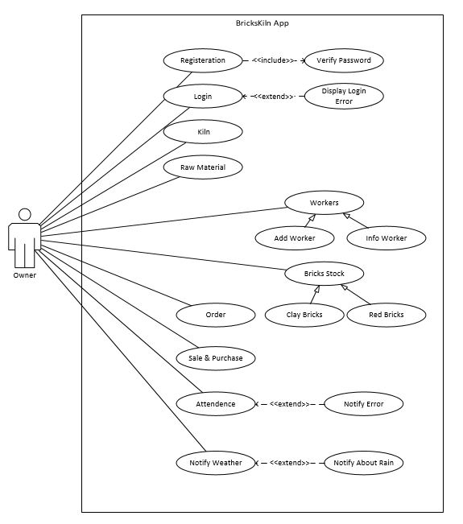
Figure C: High Level Use Case

2.11. Analysis Level Use Case Diagram:

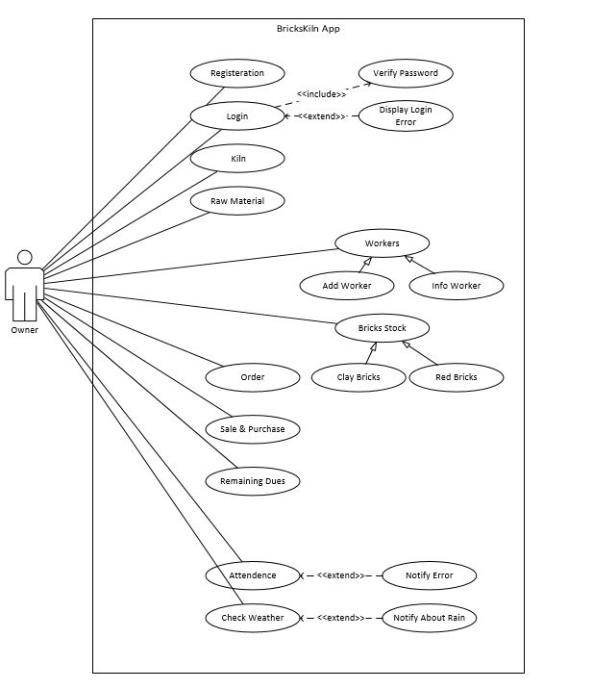
Figure D: Analysis Level Use Case

2.12. Use Case Description

Use Case ID: | UC-01
Use Case Name: | UC-Registration
Actors: | Owner
Description: | The user makes an account to use the application.
Trigger: | User taps ‘Registration’ button.
Preconditions: | The application should be installed.
Post conditions: | The user account has been created successfully.
Normal Flow: | - The user installs the application.  - The system asks the user to create a new account if he is new user.  - The user requires entering the information to create an account which includes mobile number and password.
Alternative Flows: | No alternate flow for registration.
Exceptions: | The user may type the incorrect Mobile number as a result of which the system displays error message along with the option to re-enter.
Includes: | Require Internet Connection
Special Requirements: | Security
Assumptions: | The user knows how to use a cell phone.
Notes and Issues: | - It is necessary to create an account in order to use application.  - The minimum character length of password is 15 characters.

Use Case ID: | UC-02
Use Case Name: | UC-Login
Actors: | Owner
Description: | The user logs in to the system.
Trigger: | User taps the ‘I already have an account’ button.
Preconditions: | The user should already be registered.
Post conditions: | The user shall use the application after logging in.
Normal Flow: | - The user enters the mobile number and password.  - The system confirms it and allows the user to use the application.
Alternative Flows: | No alternate for login to the application.
Exceptions: | The user enters the wrong mobile number or password
Includes: | Registration
Special Requirements: | Security
Assumptions: | The user knows how to use a cell phone.
Notes and Issues: | - It is necessary to be already registered.  - The entered password must match with the database.

Use Case ID: | UC-03
Use Case Name: | UC-Verification
Actors: | Owner
Description: | The system verifies the login credentials.
Trigger: | User taps the ‘Login button.
Preconditions: | The user should enter correct mobile number and password.
Post conditions: | The user shall use the application after verification and recover his password as failure in verification.
Normal Flow: | - The user should enter the correct mobile number and password.  - The system shall verify automatically user’s password and mobile number from the database.
Alternative Flows: | No alternate for verification
Exceptions: | The user enters the wrong mobile number or password.
Includes: | Registration
Special Requirements: | Security
Assumptions: | The user knows how to use a cell phone.
Notes and Issues: | It is necessary to enter correct mobile number and password.

Use Case ID: | UC-04
Use Case Name: | UC-Add Kiln
Actors: | Owner
Description: | The user shall add kiln
Trigger: | User taps the ‘Add Kiln button.
Preconditions: | The user should be login to the application.
Post conditions: | The user shall select factory successfully.
Normal Flow: | The system shall normally add kiln.
Alternative Flows: | No alternate for factory selection.
Exceptions: | The user enters the invalid or incomplete information as a result system give an error message to complete and valid information.
Includes: | Login
Special Requirements: | Security
Assumptions: | The user knows how to use a cell phone.
Notes and Issues: | It is necessary to have information about kiln.

Use Case ID: | UC-05
Use Case Name: | UC-Raw Materials
Actors: | Owner
Description: | The user shall see the record of raw materials.
Trigger: | User taps the ‘Raw Materials’ button.
Preconditions: | The user should be login to the application
Post conditions: | The user shall keep the record of raw materials.
Normal Flow: | The shall see the raw material’s record e.g. clay, sand and coal.
Alternative Flows: | No alternate for raw materials
Exceptions: | The user enters the invalid or incomplete information as a result system give an error message to complete and valid information.
Includes: | Login
Special Requirements: | Performance
Assumptions: | The user knows how to use a cell phone.
Notes and Issues: | It is necessary to have materials information.

Use Case ID: | UC-06
Use Case Name: | UC-Order
Actors: | Owner
Description: | The user shall keep the record of orders.
Trigger: | User taps the ‘Order’ button.
Preconditions: | The system should have existing order or enter new order.
Post conditions: | The system shall show the record of orders
Normal Flow: | The user should see and manage the record of orders
Alternative Flows: | No alternate for order.
Exceptions: | The user enters the invalid or incomplete information as a result system give an error message to complete and valid information.
Includes: | Login
Special Requirements: | Performance
Assumptions: | The user knows how to use a cell phone.
Notes and Issues: | It is necessary to correct information about order

Use Case ID: | UC-07
Use Case Name: | UC-Sale and Purchase Record
Actors: | Owner
Description: | The system shall generate the sale and purchase record.
Trigger: | User Taps the ‘Sale and Purchase’ button.
Preconditions: | The user should be login to the application
Post conditions: | The user shall view sale and purchase summary.
Normal Flow: | The user should view the generated purchase summary.
Alternative Flows: | No alternate of sale and purchase record.
Exceptions: | The user enters the invalid or incomplete information as a result system give an error message to complete and valid information.
Includes: | Login
Special Requirements: | Performance, accuracy
Assumptions: | The user knows how to use a cell phone.
Notes and Issues: | It is necessary to have information about sale and purchase record.

Use Case ID: | UC-08
Use Case Name: | UC-Attendance
Actors: | Owner
Description: | The user shall keep the attendance of workers.
Trigger: | The user taps ‘Attendance’ button
Preconditions: | The system should have database of workers.
Post conditions: | The user shall take attendance of workers.
Normal Flow: | The system shall be to take attendance by detecting face.
Alternative Flows: | No alternate of attendance.
Exceptions: | The system should generate error if worker is not in the database.
Includes: | Login
Special Requirements: | Performance, availability
Assumptions: | The user knows how to use a cell phone.
Notes and Issues: | It is necessary to have worker’s information

Use Case ID: | UC-09
Use Case Name: | UC-Notification Alert
Actors: | Owner
Description: | The system shall notify the user about any information.
Trigger: | User taps the ‘View Notification’ button
Preconditions: | The user should login to the application.
Post conditions: | The user shall view the notifications.
Normal Flow: | The user should view the notifications.
Alternative Flows: | No alternate flow of notification.
Exceptions: | The user enters the invalid or incomplete information as a result system give an error message to complete and valid information.
Includes: | Login
Special Requirements: | Performance, accuracy
Assumptions: | The user knows how to use a cell phone.
Notes and Issues: | It is necessary to enter correct and complete information

Use Case ID: | UC-10
Use Case Name: | UC-Workers
Actors: | Owner
Description: | The system shall keep the information about worker.
Trigger: | User taps the ‘Workers’ button
Preconditions: | The user should login to the application.
Post conditions: | The user shall view the worker’s detail.
Normal Flow: | The user should view the details.
Alternative Flows: | No alternate flow.
Exceptions: | It will generate an error if workers information is not in database.
Includes: | Login
Special Requirements: | Performance, accuracy
Assumptions: | The user knows how to use a cell phone.
Notes and Issues: | It is necessary to workers in database

Use Case ID: | UC-11
Use Case Name: | UC-Bricks Stock
Actors: | Owner
Description: | The system shall keep the record about stock of bricks.
Trigger: | User taps the ‘Bricks Stock’ button
Preconditions: | The user should login to the application.
Post conditions: | The user shall view the records.
Normal Flow: | The user should view the records
Alternative Flows: | No alternate flow.
Exceptions: | The user enters the invalid or incomplete information as a result system give an error message to complete and valid information.
Includes: | Login
Special Requirements: | Performance, accuracy
Assumptions: | The user knows how to use a cell phone.
Notes and Issues: | It is necessary to have stock of bricks

Use Case ID: | UC-12
Use Case Name: | UC-Remaining Due
Actors: | Owner
Description: | The system shall keep record of remaining due.
Trigger: | User taps the ‘Remaining Due’ button
Preconditions: | The user should login to the application.
Post conditions: | The user shall view the remaining dues.
Normal Flow: | The user should view the records.
Alternative Flows: | No alternate flow of notification.
Exceptions: | The user enters the invalid or incomplete information as a result system give an error message to complete and valid information.
Includes: | Login
Special Requirements: | Performance, accuracy
Assumptions: | The user knows how to use a cell phone.
Notes and Issues: | It is necessary to enter correct and complete information

Use Case ID: | UC-13
Use Case Name: | UC-Weather Information
Actors: | Owner
Description: | The system shall notify the user about weather.
Trigger: | User taps the ‘Weather Information’ button
Preconditions: | The user should login to the application.
Post conditions: | The user shall view the information about weather.
Normal Flow: | The user should view the information about weather.
Alternative Flows: | No alternate flow.
Exceptions: | No exceptions
Includes: | Login
Special Requirements: | Performance, accuracy
Assumptions: | The user knows how to use a cell phone.
Notes and Issues: | It is necessary to connected to the Wi-Fi to get information about weather

Chapter 3: Design Document (For Object Oriented Approach)

Introduction:
Third deliverable is all about the software design. In the previous deliverable, analysis of the system is completed. So, we understand the current situation of the problem domain. Now we are ready to strive for a solution for the problem domain by using object-oriented approach. Following artifacts must be included in the 3rd deliverable.
- Domain Model
- Sequence Diagram
- Collaboration Diagram
- Design Class Diagram
- Entity Relationship Diagram
Now we discuss these artifacts one by one as follows:

3.2. Domain Model
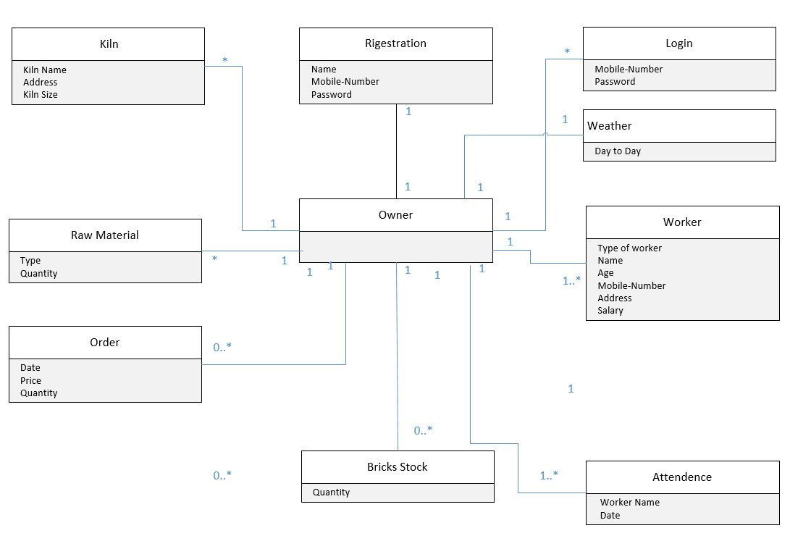
Figure E: Domain Model

3.3 Sequence Diagram

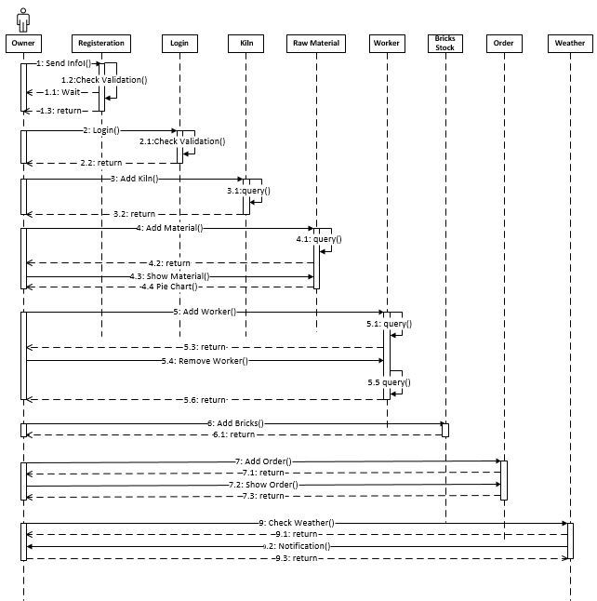

Figure F: Sequence Diagram

3.4. Collaboration Diagram

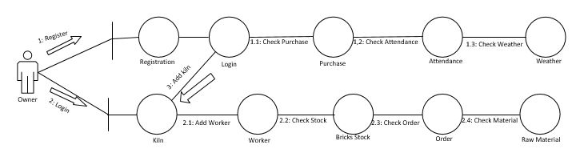

Figure G: Collaboration Diagram

3.5. Class Diagram

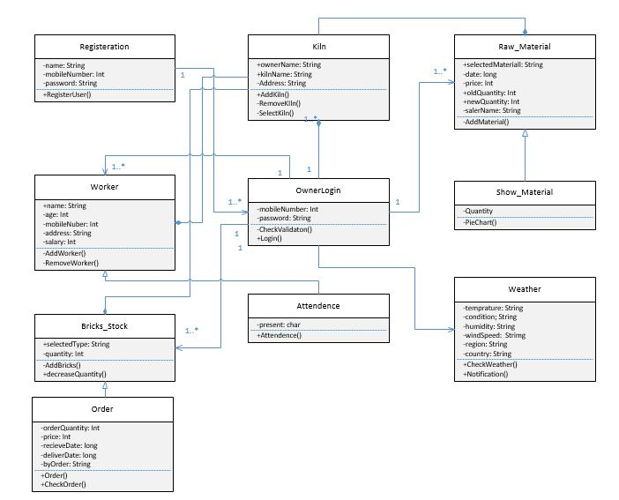

Figure H: Class Diagram

3.6. Entity Relationship Diagram (ERD)

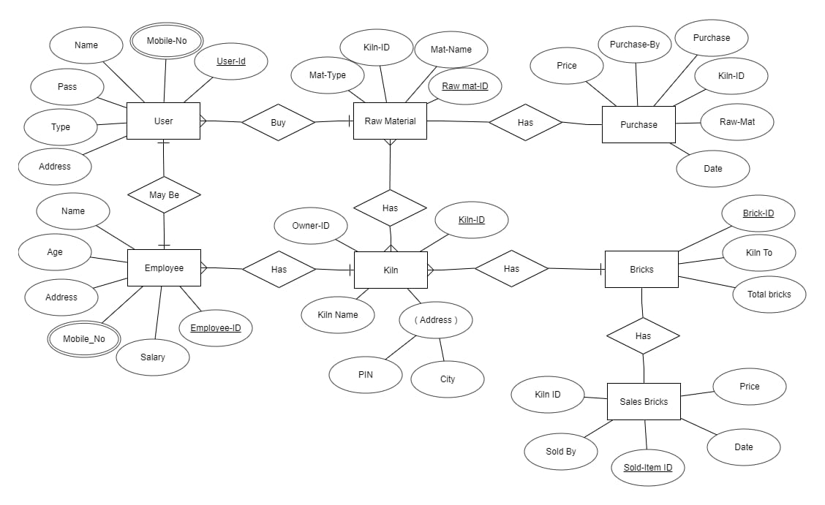
Figure I: Entity Relationship Diagram (ERD)

Chapter 4: User Interface Design

4.1. Introduction
A user interface design consists of three main parts:
- Site maps
- User Manual
- Navigational Maps

4.2. Site Maps
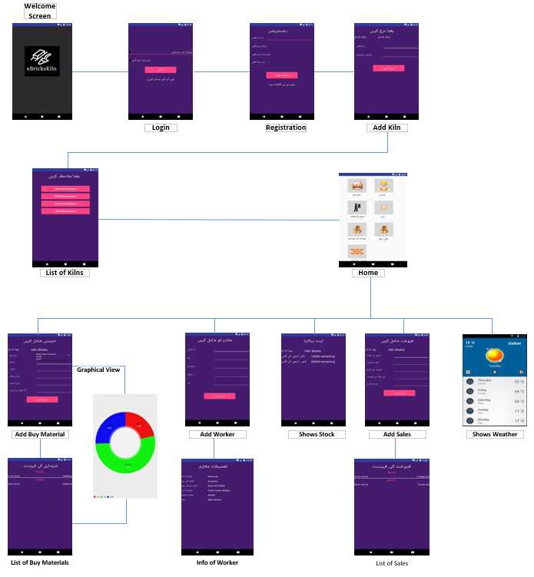
Figure J: Site Maps

4.3. User Manual
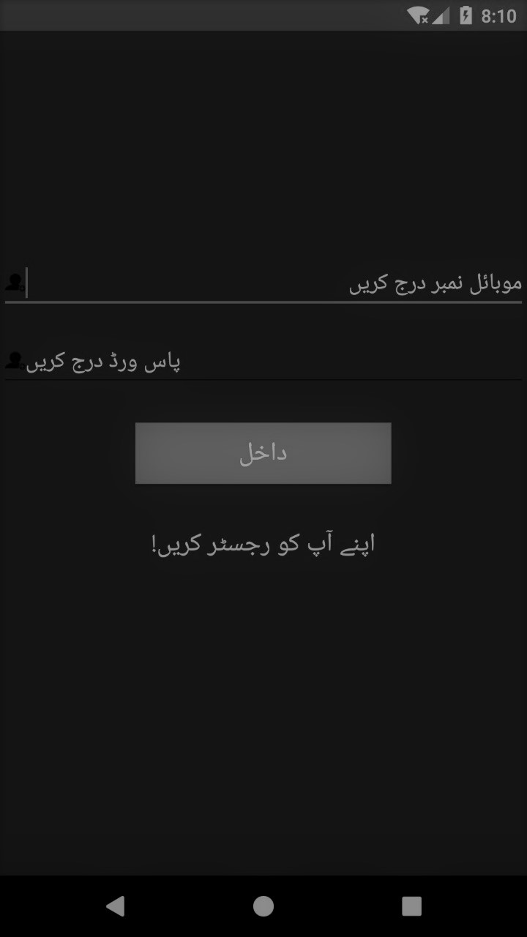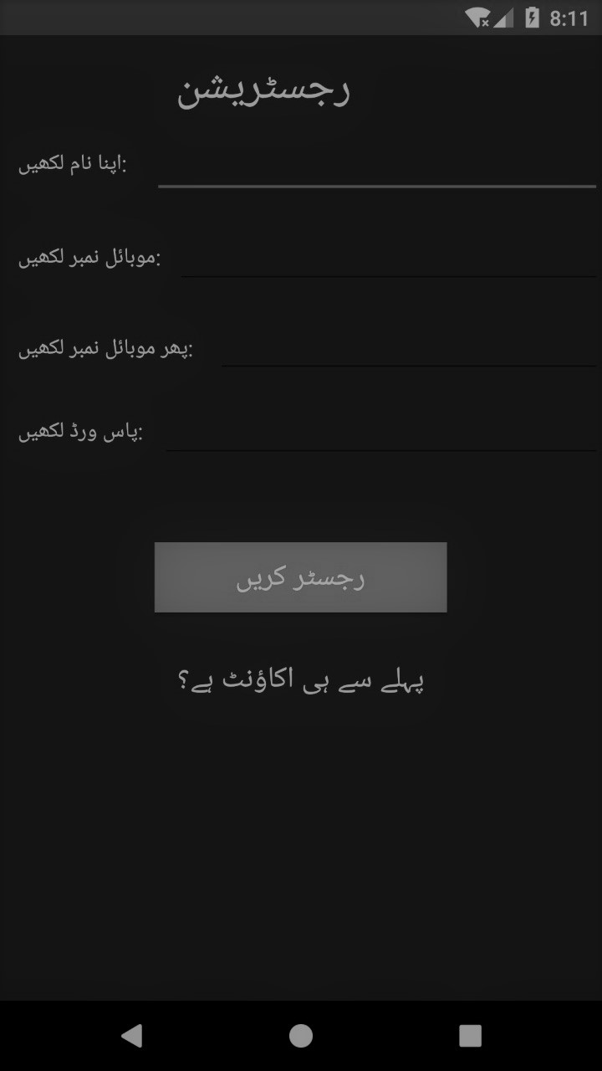

Figure K: Login Figure L: Registration

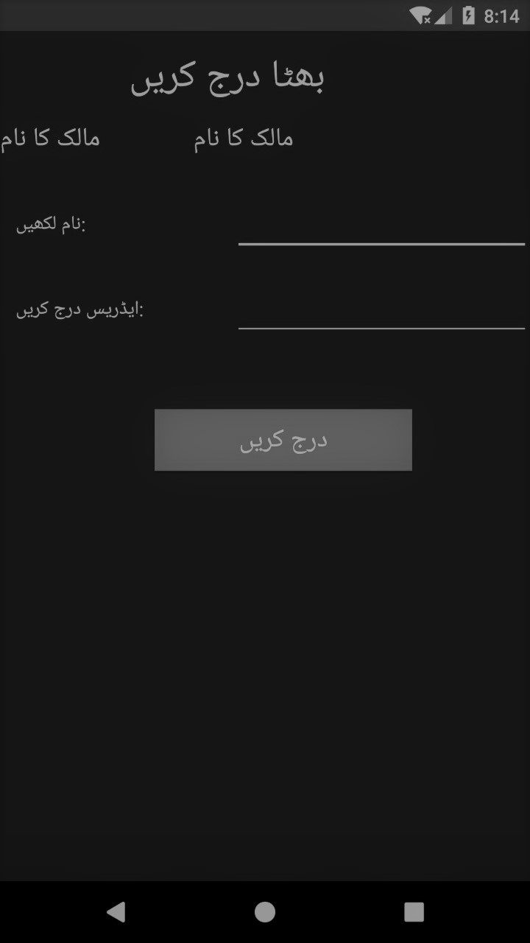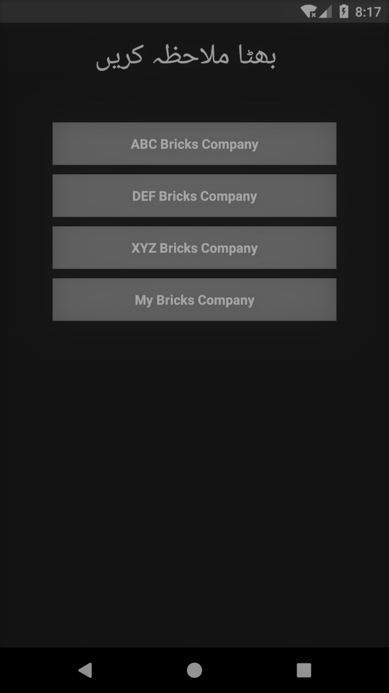

Figure M: Add Kiln Figure N: List of Kilns

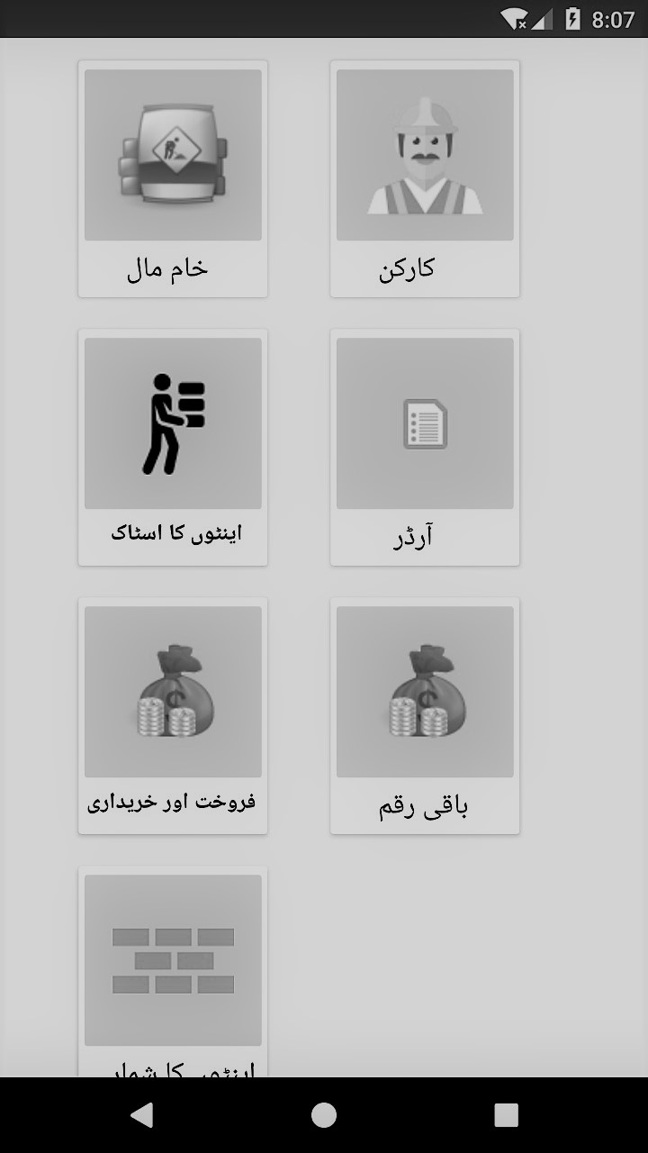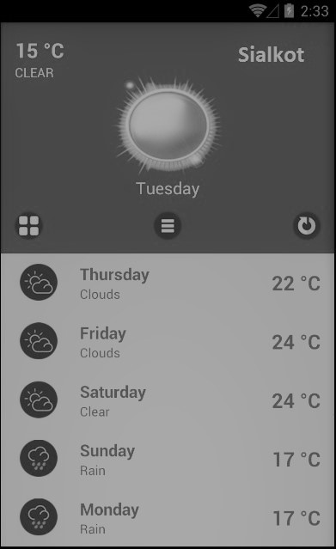

Figure O: Home Figure P: Shows Weather

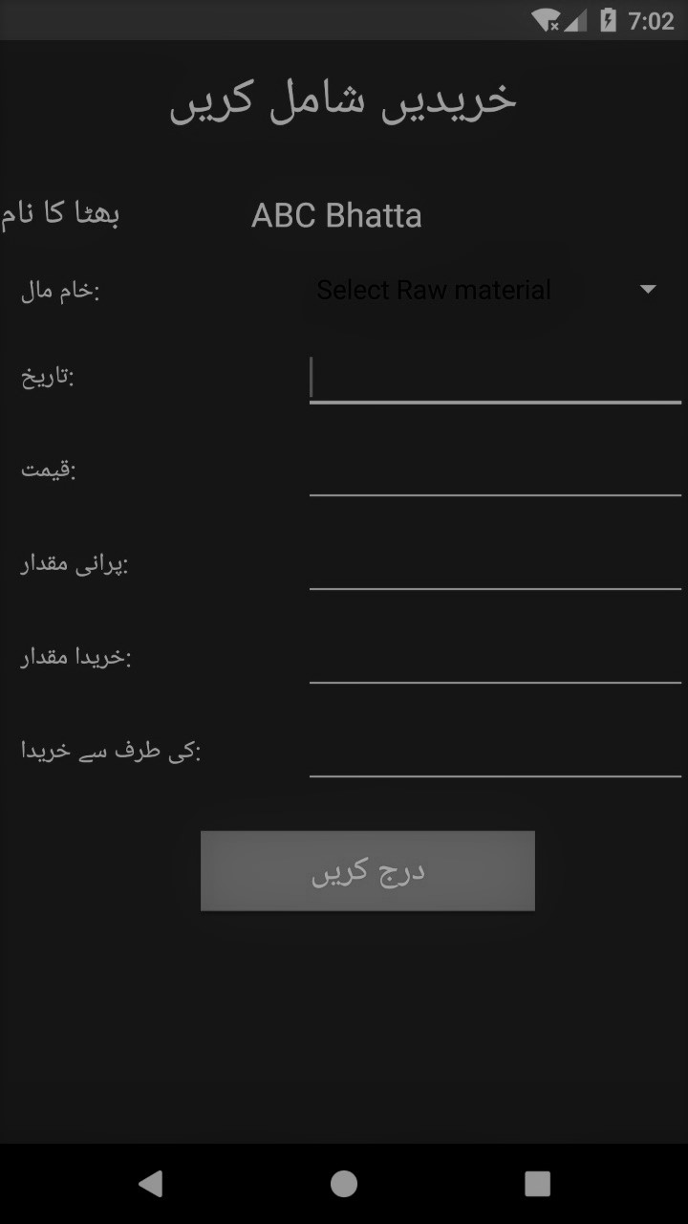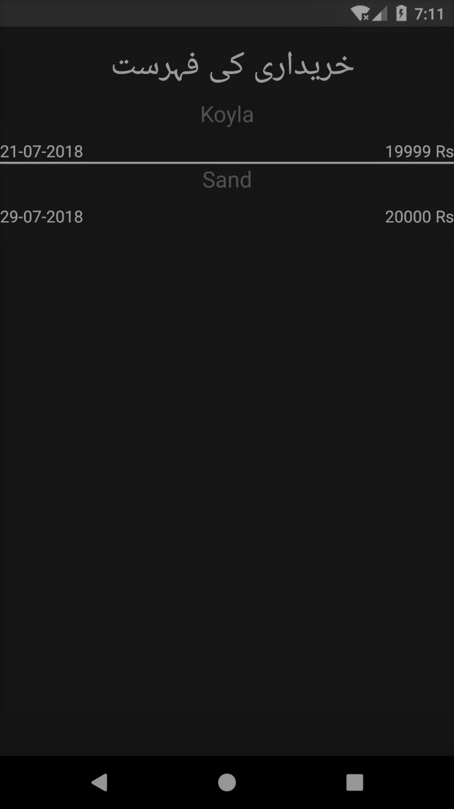

Figure Q: Add/Buy Materials Figure R: List of Buy Materials

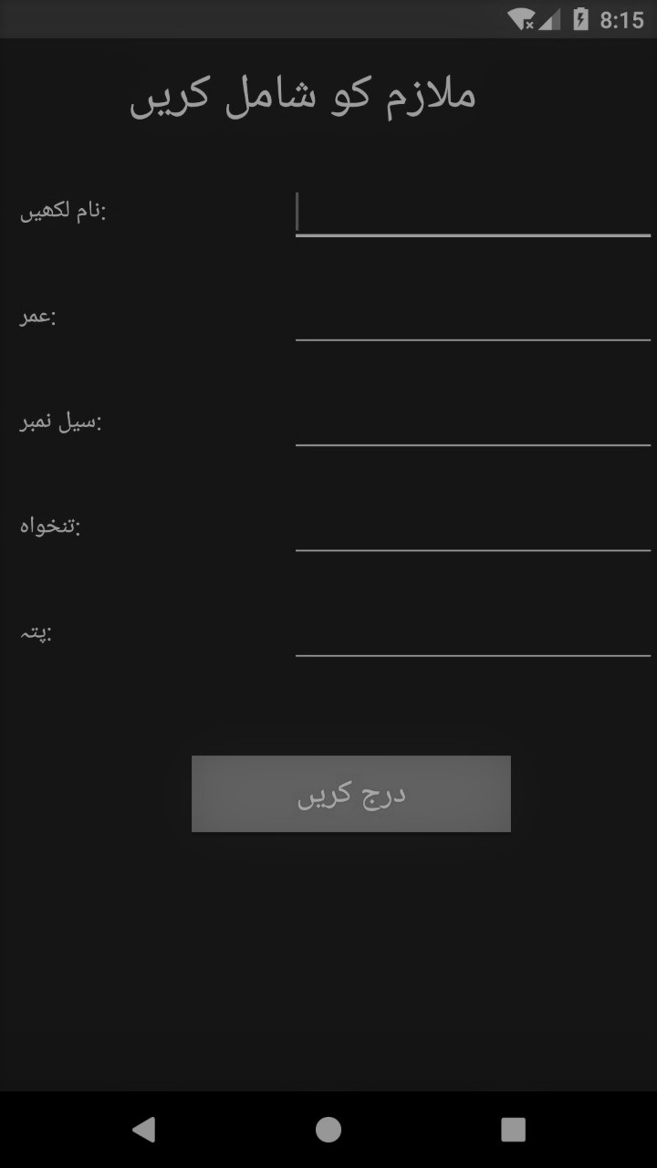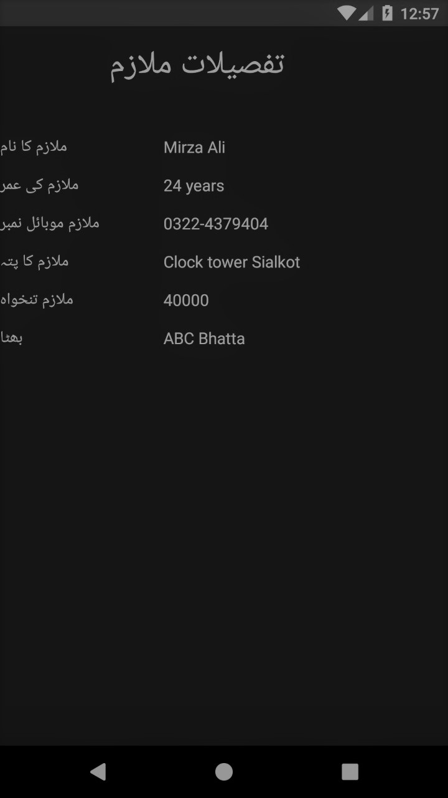

Figure S: Add Worker Figure T: Info of Workers

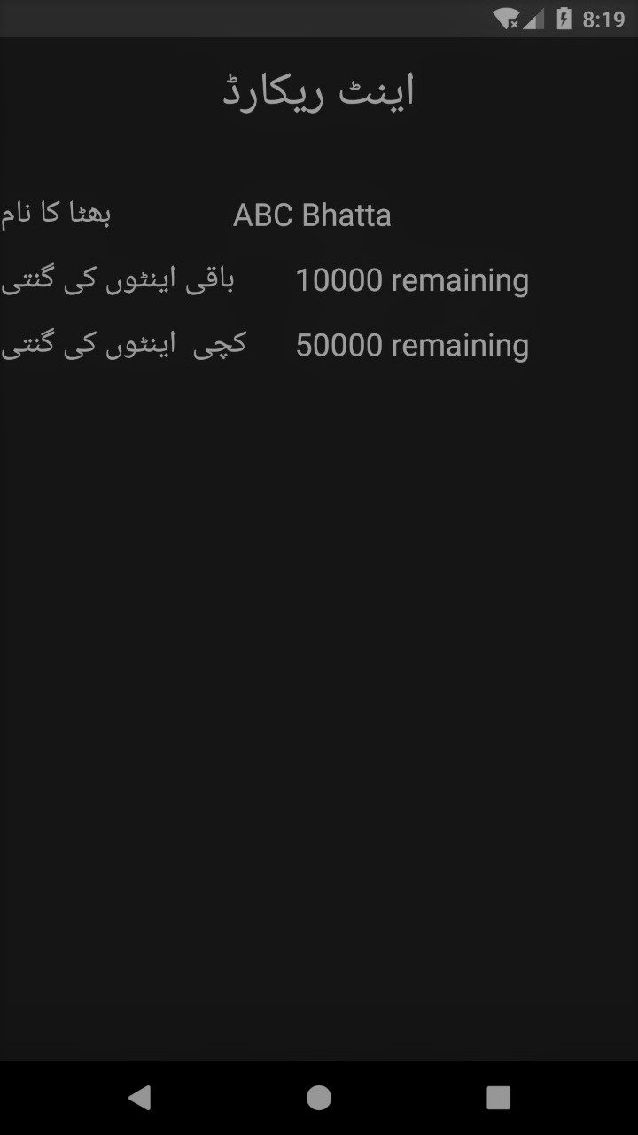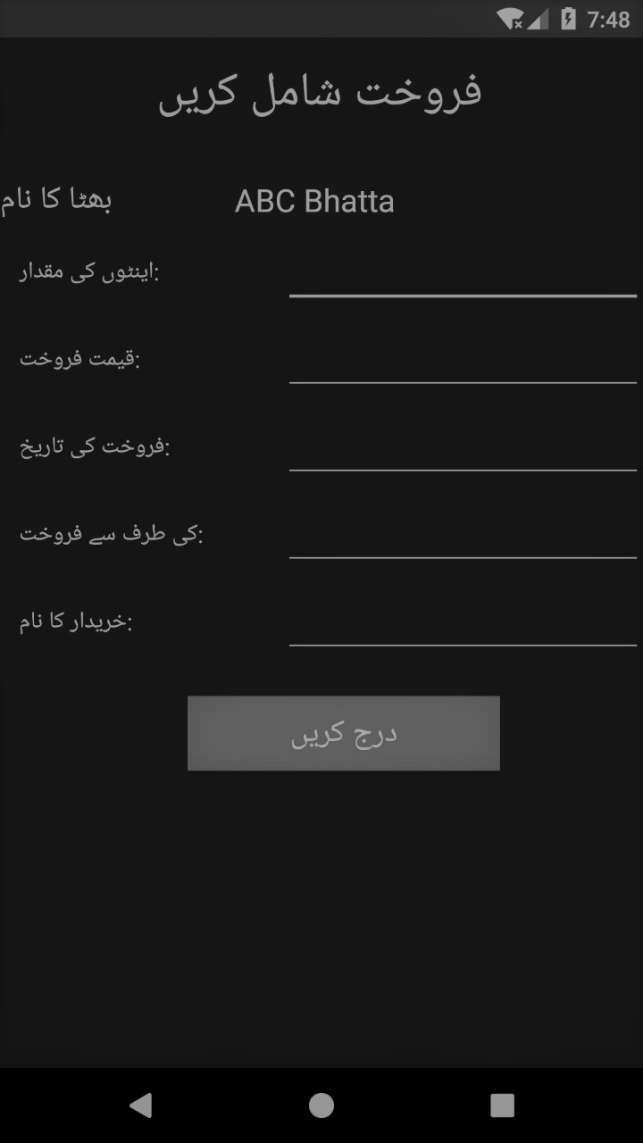

Figure U: Shows Stock Figure V: Add Sales

4.4. Navigational Maps:

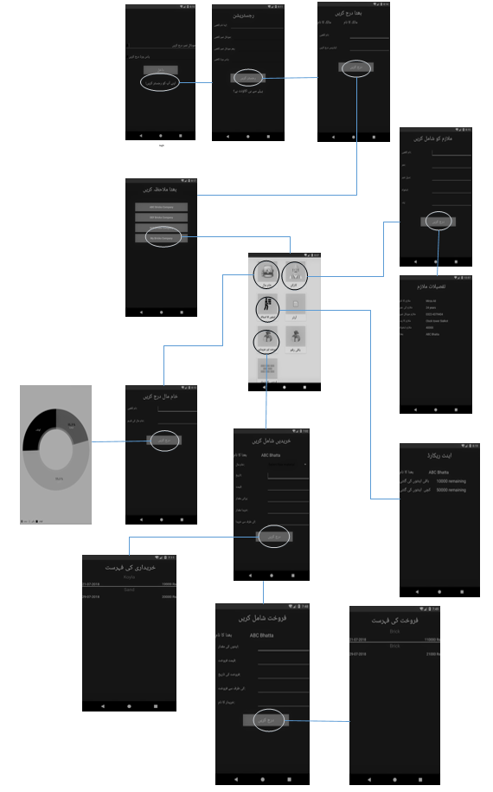
Figure W: Navigational Maps

Chapter 5: Software Testing

5.1 Introduction:
From the start of software engineering different software testing schemes and testing templates has invented. These testing templates are used to test both UI and unit testing. Every credible software house developed their testing documentation for the purpose of developing efficient systems. To provide a common set of standardized documents the IEEE developed the 829 Standard for Software Test Documentation for any type of software testing. In our testing module we are going to test different features and modules
of the system.

5.2. Test plan

5.2.1. Purpose
To prescribe the scope, approach, resources, and schedule of the testing activities. To identify the items being tested, the features to be tested, the testing tasks to be performed and the risks associated with this plan.

5.2.2. Outline
A test plan shall have the following structure:
- Test plan identifier
- Introduction
- Test items
- Features to be tested
- Features not to be tested
- Approach
- Item pass/fail criteria
- Suspension criteria and resumption requirements
- Test deliverables
- Testing tasks
- Environmental needs
- Responsibilities
- Staffing and training needs
- Schedule
- Risks and contingencies

5.2.2.1. Test plan identifier
The identifier for test plan is eBK_AFTP.01. The abbreviation for the identifier is as:
eBK BricksKiln
AFTP All Feature Test Plan
  - Version 1 and Revision 1

5.2.2.2. Introduction
Software test planning is the most core part of the testing phase on which all the other phases depends in one or another way.

Test planning phases defines and elaborate following points:

  - What tester has to perform in testing
  - Standards of quality to use in testing,
  - Resources to be employed for testing,
  - Schedule and time scale for the testing phase
  - Describes all the risk and contingencies which involved in testing and how they will be overcome.

5.2.2.3. Test items

Following are the testing items which we are going to test in this plan

- External Database Connection
- Login User
- Sign Up User
- Online Database
- Add Kiln Fragment
- Remove Kiln Fragment
- Order Fragment
- Raw Material Fragment
- Weather App Fragment

All these are generalized items which will in fact contain different tests to remove anomalies and defects from the Project.

5.2.2.4. Features to be tested
Following is the list of all the feature which will be tested:

- Correct signup username
- Correct password signup
- No empty field in signup
- No empty field in the login
- Correct username in login
- Correct password in login
- Signup button working as desired
- Login button working as desired
- Add New Kiln
- Remove Existing Kiln
- Raw Material
- Labor Database
- Order Module
- Sale and Purchase
- Stock of Bricks
- Weather Information
- Attendance

5.2.2.5. Features not to be tested
Following are the features which will not be tested in our project:
1) JSON Parsing
2) Query Testing
3) PHP Files
4) Third Party Libraries

5.2.2.6. Approach
We are going to use Following testing technique provided in android to test our project.
1) Unit Testing
2) Instrumental or Integrational Test
Now unit testing covers almost 70 percent of program test. So, we will be using unit test extensively to test each and every component of our project possibly.
Moreover, Instrumentation tests are used to test the UI of the android app. They cover 30 percent of total test coverage.

5.2.2.7. Item pass/fail criteria
There will be different criteria for the Unit testing and Instrumentation testing for the passing and failure of a testing. Moreover, we will be using test driven approach in our development of app. It means we are going to first write test and the execute them and after test will be failed we will write the code required to pass the test. After that we will refactor and again test till we pass all the test which are designed and written.

Pass/Fail Criteria for Unit Testing:
1) A unit test will be considered as completed if it evaluates that the functionality which is tested is also there in the project.
2) A unit test will be considered as fail if the time out happens during testing.

Pass/Fail Criteria for Instrumentation Testing:
A test will be considered as pass if it will perform the desired operation on UI and the result in the UI is displayed as expected.
Now all the tests which will not follow above criteria will be deemed as flaky test and also considered as fail test.

5.2.2.8. Suspension criteria and resumption requirements
The criteria for the suspension and resumption of testing shall be as follow:
1) If number or types of defects reach a point where the follow-on testing has no value, it will make no sense to continue testing. In this case we will be sending tests for further reviews and development.
- After completion of development and reviews and refactoring, testing shall resume.

5.2.2.9. Test deliverables

The following deliverable will be provided after the testing efforts ends:
1) Test Plan
2) Test Report
3) Test Cases
4) Test Coverage
5) Implemented System with defects
6) Implemented system without defects

5.2.2.10. Testing tasks
Following tasks should be completed before the testing:
- Latest Android Studio Installed.
- Design and plan test in order to write and execute them.

5.2.2.11. Environmental needs
We need a physical android device or an android emulator installed at Android studio to smoothly run instrumented tests.

5.2.2.12. Responsibilities
Following are the responsibility table depicting jobs of different team members in planning, designing and executing tests.

Testing Module | Performed By
Test Planning | Mohsin Hanif
Test Specification | Noman Liaqat
Test Case Development | Farwa Kanwal
Test Writing | M.Osama Waheed
Test Execution | Mohsin Hanif

Table 10: Responsibilities

5.2.2.13 Staffing and training needs
- To apply systematic testing methods, test team require a complete understanding of software testing.
- To apply test in android and to understand them a person requires complete knowledge of testing components provided by android.
- Training for the team members can be organized to get understanding of testing frameworks.

5.2.2.14. Schedule
Attached is the full schedule of development of project. You can see that testing is scheduled to be performed in the last two weeks of July 2018.
Figure X: Gantt Chart

5.2.2.15. Risks and contingencies
Some of the potential actions to be taken as a part of resolution of planning risks and contingencies are listed below.

- The system will be rejected by the end user if they found it less interactive and difficult to use after adding new feature.
- A proper documentation of requirement specification subsequently system specification is crucial. In the absence of these documents test failure can be the resultant of our effort.
- All requirements and feature should be provided and cross checked before the application is delivered to the client.

5.3. Test design specification

5.3.1. Purpose
Test design specification deals with the designing about the features which we are going to test. In this phase we also prioritize the test cases in their order of importance.

5.3.2. Outline
Following is the content which we are going to describe in test design specification.
- Test design specification identifier
- Feature to be Tested
- Approach Refinement
- Testing identification
- Feature Pass Fail Criteria

5.3.3 Test design specification identifier

The identifier for the test design specification is eBK_DSI

5.3.4 Features to be tested
Following is the list of all the feature which will be tested:
- Correct signup username
- Correct password signup
- No empty field in signup
- No empty field in the login
- Correct username in login
- Correct password in login
- Signup button working as desired
- Login button working as desired
- Add New Kiln
- Remove Existing Kiln
- Raw Material
- Labor Database
- Order Module
- Sale and Purchase
- Stock of Bricks
- Weather Information
- Attendance

5.3.5 Approach refinements

We will be using the same strategy and approach as mentioned in the test plan phase.

5.3.6 Testing identification

In this phase we make a list of testing features which can be tested and can be taken as a test case in the future steps of testing.
In our testing strategies we are taking all the test items as test cases.

5.3.7 Feature pass/fail criteria
There will be different criteria for the Unit testing and Instrumentation testing for the passing and failure of a testing. Moreover, we will be using test driven approach in our development of app. It means we are going to first write test and the execute them and after test will be failed we will write the code required to pass the test. After that we will refactor and again test till we pass all the test which are designed and written.

Pass/Fail Criteria for Unit Testing:
1) A unit test will be considered as completed if it evaluates that the functionality which is tested is also there in the project.
2) A unit test will be considered as fail if the time out happens during testing.

Pass/Fail Criteria for Instrumentation Testing:
A test will be considered as pass if it will perform the desired operation on UI and the result in the UI is displayed as expected.
Now all the tests which will not follow above criteria will be deemed as flaky test and also considered as fail test.

5.4. Test Case Specification

5.4.1. Purpose
To define a test case identified by a test design specification.

5.4.2. Outline
Following are the contents of test case specification:
- Test case specification identifier
- Test items
- Input specifications
- Output specifications

5.4.2.1. Test case specification identifier
Following are the test case identifiers that will be used in our test:

Serial No | Test Case Input | Test Case Identifier
1 | Correct signup username | TC1
2 | Correct password signup | TC2
3 | No empty field in signup | TC3
4 | No empty field in the login | TC4
5 | Correct username in login | TC5
6 | Correct password in login | TC6
7 | Signup button working as desired | TC7
8 | Login button working as desired | TC8
9 | Add New Kiln | TC9
10 | Remove Existing Kiln | TC10
11 | Raw Material | TC11
12 | Labor Database | TC12
13 | Order Module | TC13
14 | Sale and Purchase | TC14
15 | Stock of Bricks | TC15
16 | Weather Information | TC17
17 | Attendance | TC18

Table 11: Test case specification identifier

5.4.2.2 Test items

- Correct signup username
- Correct password signup
- No empty field in signup
- No empty field in the login
- Correct username in login
- Correct password in login
- Signup button working as desired
- Login button working as desired
- Add New Kiln
- Remove Existing Kiln
- Raw Material
- Labor Database
- Order Module
- Sale and Purchase
- Stock of Bricks
- Weather Information
- Attendance

5.4.2.3. Input specifications
Here we will specify the input for every test case:

Serial No | Test Case Input | Test Case Identifier
1 | Signup Username Text | TC1
2 | Signup Password Text | TC2
3 | Signup.xml layout elements | TC3
4 | Login.xml layout elements | TC4
5 | Login Username Text | TC5
6 | Login Password Text | TC6
7 | Signup button access | TC7
8 | Login button access | TC8
9 | Add New Kiln | TC9
10 | Remove Existing Kiln | TC10
11 | Raw Material | TC11
12 | Labor Database | TC12
13 | Order Module | TC13
14 | Sale and Purchase | TC14
15 | Stock of Bricks | TC15
16 | Weather Information | TC17
17 | Attendance | TC18

Table 12: Input specification

5.4.2.4. Output specifications

Serial No | Test Case Output | Test Case Identifier
1 | Specify whether username is according to pattern. | TC1
2 | Specify whether password is according to pattern. | TC2
3 | Specify whether a field is empty or not | TC3
4 | Specify whether a field is empty or not | TC4
5 | Specify whether username is correct or not | TC5
6 | Specify whether password is correct or not | TC6
7 | Specify whether Signed up or not | TC7
8 | Specify whether User Login or not | TC8
9 | Specify whether new kiln added or not | TC9
10 | Specify whether kiln removed or not | TC10
11 | Specify whether list of raw materials displayed or not | TC11
12 | Specify whether labor database displayed or not | TC12
13 | Specify whether order data is retrieved or not. | TC13
14 | Specify whether sale and purchase are written or not | TC14
15 | Specify whether stock of bricks is displayed or not | TC15
16 | Specify whether bricks counted successfully or not | TC16
17 | Specify whether the weather is informed or not | TC17
18 | Specify whether the attendance is marked or not | TC18

Table 13: Output specification

5.5. Test procedure specification

5.5.1. Purpose
To specify the steps for executing a set of test cases or, more generally, the steps used to analyze a software item in order to evaluate a set of features.

5.5.2 Outline
Following are the contents of test procedure specification:

- Test procedure specification identifier
- Special requirements
- Procedure steps

5.5.2.1. Test procedure specification identifier
The identifier for the test procedure specification is “eBK_TPSI”

5.5.2.2. Special requirements
To proceed with the testing in android one should have knowledge of following techniques:

- Unit testing
- UI testing

5.5.2.3. Procedure steps
Following are the procedural steps for the successful execution of tests.

5.5.2.3.1. Set up
- Install Android Studio
- Install Android Emulator
- Execute the Test
- Generate test coverage report.

5.5.2.3.2. Start
We need to plan and design the test before executing them in android studio. Once we write all the test we will run UI test.

5.5.2.3.3. Proceed
We have to execute test cases in the order of their dependency. Test cases with no dependencies or solved dependencies first.

5.5.2.3.4. Measure
The measurement whether a test is correct or not is solely based on the human observation.

5.5.2.3.5. Shut down
To shut down the testing we have to stop testing forcefully using android studio or we can run a command on android gradle.

5.5.2.3.6. Restart
To restart the test simply click on the android studio folder where the test resides and click the option of restart test.

5.5.2.3.7. Stop
To stop the test orderly, we will have to wait for the competition of execution.

5.5.2.3.8. Wrap up
Now to test the code again we will again change the execution mode.

5.5.2.3.9. Contingencies
Contingencies can be reported or tested whenever you maintain test logs.

5.6. Test item transmittal report

5.6.1. Purpose
To identify the test items being transmitted for testing. It includes the person responsible for each item, its physical location, and its status. Any variations from the current item requirements and designs are noted in this report.

5.6.2. Outline
Following are the contents of test case specification:

- Transmittal report identifier
- Transmitted items
- Location
- Status

5.6.2.1. Transmittal report identifier
The identifier for the transmittal report is eBK_TRI.

5.6.2.2. Transmitted items
All the items which are mentioned in the Test Plan are part of the test transmittal report. We should also provide all those tests which are failed and again revised and developed for refactoring for further testing.

5.6.2.3. Location
All the test document including most important test case specification will be placed in a PDF file and will be transmitted to test manager and test executor by email.
After receiving email tester will be able to convert test case specifications into actual written test cases.

5.6.2.4. Status
At this phase all the test cases which are provided are not tested prior so their status is un resolved or we can say false. After the testing will be done then if there will be any problem in the code, a request will be made to the developers to again correct and refactor the code.

5.7. Test log

5.7.1. Purpose
To provide a chronological record of relevant details about the execution of tests.

5.7.2. Outline
Following will be the content of Test Log.
- Test log identifier
- Description
- Activity and event entries

5.7.2.1. Test log identifier
The identifier for Test Log is eBK_TLI

5.7.2.2. Description.
Here are all the test items which are planned to be tested and also are transmitted to the test manager.

Serial No | Test Case Input | Test Case Identifier
1 | Correct signup username | TC1
2 | Correct password signup | TC2
3 | No empty field in signup | TC3
4 | No empty field in the login | TC4
5 | Correct username in login | TC5
6 | Correct password in login | TC6
7 | Signup button working as desired | TC7
8 | Login button working as desired | TC8
9 | Add New Kiln | TC9
10 | Remove Existing Kiln | TC10
11 | Raw Material | TC11
12 | Labor Database | TC12
13 | Order Module | TC13
14 | Sale and Purchase | TC14
15 | Stock of Bricks | TC15
16 | Weather Information | TC17
17 | Attendance | TC18

Table 14: Description of Test Cases

5.7.2.3. Activity and event entries
For each event, including the beginning and end of activities, record the occurrence date and time along with the identity of the author.

5.7.2.3.1. Execution description
While executing the tests whole team was present so that all of the team get through understanding of testing process.
The tests were executed on July 27, 2018

5.7.2.3.2. Procedure results
Following is the complete result of our test execution based on the pass/fail criteria already mentioned in planning phase.

Serial No | Test Case Identifier | Test Revisions | Test Case Result | Test Status
1 | TC1 | 1st | Specify whether username is according to pattern. | Pass
2 | TC2 | 1st | Specify whether password is according to pattern. | Pass
3 | TC3 | 1st | Specify whether a field is empty or not | Pass
4 | TC4 | 1st | Specify whether a field is empty or not | Pass
5 | TC5 | 1st | Specify whether username is correct or not | Pass
6 | TC6 | 1st | Specify whether password is correct or not | Pass
7 | TC7 | 1st | Specify whether Signed up or not | Pass
8 | TC8 | 1st | Specify whether User Login or not | Pass
9 | TC9 | 1st | Specify whether new kiln added or not | Pass
10 | TC10 | 1st | Specify whether kiln removed or not | Fail
11 | TC11 | 1st | Specify whether list of raw materials displayed or not | Pass
12 | TC12 | 1st | Specify whether labor database displayed or not | Pass
13 | TC13 | 1st | Specify whether order data is retrieved or not. | Pass
14 | TC14 | 1st | Specify whether sale and purchase are written or not. | Pass
15 | TC15 | 1st | Specify whether stock of bricks is displayed or not | Pass
16 | TC16 | 1st | Specify whether bricks counted successfully or not | Fail
17 | TC17 | 1st | Specify whether the weather is informed or not | Pass
18 | TC18 | 1st | Specify whether the attendance is marked or not | Pass

Table 15: Procedure results

5.7.2.3.3. System Specification
- Android Studio 3.0.1
- Android Marshmallow (minimum)

5.7.2.3.4. Anomalous events
Our tests are successfully passed at the moment and no anomaly occurred. But once developer start writing more code, problems can occur at any time. So, it is necessary to use test driven approach.

5.7.2.3.5. Incident report identifiers
Record the identifier of each test incident report, whenever one is generated.

5.8. Test incident report

5.8.1. Purpose
To document any event that occurs during the testing process that requires investigation.

5.8.2. Outline
A test incident report shall have the following structure:

- Test incident report identifier
- Summary
- Incident description
- Impact

5.8.2.1. Test incident report identifier
The identifier for incident report is eBK_IRI.

5.8.2.2. Summary
During the execution of test, we have faced an anomaly when one of the tests get failed.TC16 and TC10 are the test cases which get failed. In this section we will analyze and investigate the reason behind failure.

5.8.2.3. Incident description
Here is the complete description of the anomalies occurred during the testing phase. Also, a complete solution and refactoring is suggested in the description.

Inputs | Expected Result | Actual Result | Anomalies
Remove Kiln | Remove existing kiln | False Response | After analyzing we discover that it only removes name from list but not removing the data from database.
Table 16

Date and Time | Environment | Action | Tester | Observer
July 29, 2018 | Android Studio  Java SDK | Failure is corrected successfully and test case is dispatched for refactoring | Noman Liaqat | Farwa Kanwal

Table 17

5.8.2.4. Impact
The incident will have only impact on test case specification. We will need to rewrite test case specification for the failed test case after sorting out the issue.

5.9. Test summary report

5.9.1. Purpose
To summarize the results of the designated testing activities and to provide evaluations based on these results.

5.9.2. Outline
A test summary report shall have the following structure:
- Test summary report identifier
- Summary
- Variances
- Comprehensive assessment
- Summary of results
- Evaluation
- Summary of activities
- Approvals

5.9.2.1. Test summary report identifier
Test summary report identifier is as eBK_SRI.

5.9.2.2. Summary
All the items described in the test plan are tested and after attestation we figured out that one of them get failed. Except one test case all other test cases passed. We determine passing and failure of test cases according to the criteria mentioned above in test planning phase. After figuring out that one of the test cases is failed we prepared its incidental report so that it can be again refactored by the developer and send again. After refactoring test cases with defects, we again tested it and it passed the testing criteria.

5.9.2.3. Variances
Every test is executed according to the test plan, test specification and test case specification. We follow the testing approach and strategy stated in the test planning phase. Test were executed according to test procedure specification and they are deemed passed and failed according to testing criteria mentioned.

5.9.2.4. Comprehensiveness assessment
All the features described in the test planning phase are tested and no test case is left out of testing due to any sort of reason. Our test coverage report is more than 80 percent.

5.9.2.5. Summary of results
We send the test case back to the test planner and designer. Test planner and designer modify the test case and update transmittal report. After receiving updated transmittal report test manager again execute the revised test case and it get passed.

5.9.2.6. Evaluation
We have covered almost 80 percent code with unit and UI test. Moreover, we use test driven approach in our code. Out of all test cases only one test case gets failed which was again refactored. So, our team including test planner, test designer and test manager work in great harmony to execute all phases of testing.

5.9.2.7. Summary of activities

There are three development phases in testing. The first one was test planning followed by test specification and designing and test execution.

REFRENCES:

[1] Joe Finch, Kiln Construction: A Brick by Brick Approach, University of Pennsylvania Press, Incorporated, 2006.

[2] Frederick L. Olsen, The kiln book: materials, specifications, and construction (2nd Edition), Radnor, Pa Chilton Book Co, 1983.

[3] https://www.instructables.com/id/Image-Processing-and-Counting-using-MATLAB/

[4] http://brickkilnplus.macwill.in/

[5] Tim Jones, The Basic of Brick Kiln Technology (German Edition), Vieweg Teubner Verlag, 1996

[6] http://202.166.167.115/brick_kiln_dashboard/

[7] http://www.bkoa.com.pk/

[8] http://www.sdpi.org/sdc/12thsdc/panel_state_of_brick_kilns.html

[9] https://www.kiln-tech.com/index.php?id=74&L=1&gclid=EAIaIQobChMIkaLW3vrM3AIVCLXtCh3QaAYcEAMYASAAEgIdIvD_BwE

[10] http://www.academia.edu/Documents/in/Brick_kiln

[11] http://www.academia.edu/32768323

[12] http://www.academia.edu/6426675

[13] https://developers.google.com/android/
reference/com/google/android/gms/awareness/state/Weather

[14] https://www.000webhost.com/forum/t/000webhost-android-app/29052

[15] https://www.codeproject.com/Articles/695991/AndroidVision-Learn-Image-Processing-on-your-mobil

